Underground Petroleum Systems (UPSS)

Managing a Register of UPSS Sites

– **User Guide for Councils** –

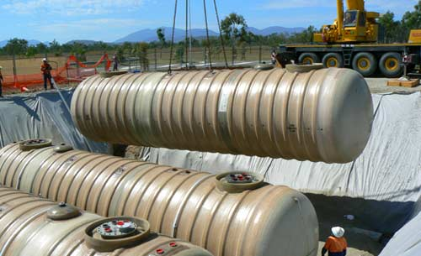

**Version:** March 2022

**Author:** Ballina Shire Council

Adapted by Riverina and Murray Joint Organisation and Riverina Eastern Organisation of Councils for its Authority Civica councils.

**Photo:** Installation of underground petroleum storage tanks from

www.nqpetro.com.au

Table of Contents

Acknowledgements 1

Introduction 1

How to use this User guide 2

Roles and Responsibilities 2

UPSS strategy 3

Authority civica upss register 10

Add / Modify a UPSS site 12

Add additional parcels 13

Add Site Operator and Owner 14

Add Checklists. 14

Add / Modify Tank record(s) 16

Add Register Links. 17

Add Site Inspection Checklist Record 21

Update Site Compliance Checklist Record 21

UPSS registers in alternative corporate IT systems 23

acknowledgements

The Council user guide for managing and updating of UPSS registers was developed by Ballina Shire Council with use of grant funds under the NSW EPA Council Regional Capacity Building (‘CRCB’) program.

The Riverina and Murray Joint Organisation (RAMJO) and Riverina Eastern Organisation of Councils (REROC) CRCB project adapted and modified the Council user guide in close consultation with the Ballina CRCB project.

West Peak Consulting Pty Ltd (Mr David Bergman) was engaged to develop, test and go-live with UPSS registers developed for RAMJO and REROC councils that use the Authority Civica enterprise resource planning (ERP) software. West Peak Consulting also provided onsite training to these councils including on the use of this user guide.

Ballina Shire Council provided the underlying dimensional framework that was used by West Peak Consulting to develop the UPSS register template.

Albury City Council assisted West Peak Consulting in the development and testing of the UPSS register template prior to its deployment.

Introduction

This user guide has been developed to assist councils navigate a process to maintain and update a register of UPSS sites in their local government area.

It is one element of a compendium of capacity resources developed for councils to guide and inform council business processes that are required to:

* Ensure land is suitable for its proposed use, and
* Minimise the risk of harm to human health and the environment, and
* Apply good practice in managing data and information on contaminated land and UPSS to ensure above objectives are achieved.

Data and information management is critical to inform any council decision-making process. Decisions regarding land suitability and minimising the risk of harm in the use of land need to be informed by data and information on contaminated land. It is also important for planning certificates under section 10 of the Environmental Planning and Assessment Act.

Such data can be found in Council’s Contaminated Land Site Register (CLSR) and in the supplementary UPSS Register. The value and currency of data and information in these registers is a function of a Council’s ability to periodically maintain and update both registers.

It is acknowledged not all council ERP’s are Authority Civica. Hence this user guide also includes general guidance for councils that have:

* No register, but a contaminated land layer in its corporate mapping system,
* ‘Static’ Microsoft Excel files as their register for contaminated land and/or UPSS,
* Alternative ERP (e.g. TechOne), and
* No register for contaminated land or UPSS.

How to use this User guide

Councils are encouraged to incorporate this user guide in its land use planning, inspectorial and electronic document and records management business processes.

The structure of this guide allows councils to easily identify the data and information management process, procedures and workflows, and steps therein.

Roles and Responsibilities

The role of council is to achieve objectives listed above in relation to land suitability and minimising the risk of harm to human health and the environment.

Hence councils are reliant on its CLSR and UPSS register to provide the necessary contaminated land data and information to guide decisions on land suitability and risk of harm.

Council staff have the following responsibilities:

* Statutory and strategic planners to update the CLSR and/or the UPSS register with information contained in a Statement of Environmental Effects relating to-
  + the assessment of site contamination (see ASC Ready Reckoner),
  + Development Application for a new or ‘significantly modified’ UPSS site (see UPSS infrastructure Ready Reckoner),
  + an assessment of the historical land use to confirm land is suitable for its proposed use, and
  + providing contaminated land information in section 10 planning certificates (see […ready reckoner name…]).
* Inspectorial functions (e.g. environmental health, compliance) to update the CLSR and/or UPSS register with outcomes from council’s inspection and monitoring operational services,
* Periodic (annual) maintenance and update of the UPSS Register with data from-
  + SafeWork NSW Schedule 11 licenced UPSS sites
  + NSW Fair Trading registered service stations (‘Fuel Check’ database)
  + NSW EPA list of contaminated land investigations
  + NSW EPA register of regulated contaminated land sites
  + NSW EPA Environmental Protection Licence database
  + Notification received from NSW EPA and/or a third party in relation to a contaminated land management process
  + Fuel companies, distributors, retailers etc (e.g. Ampol, BP, etc.)
* System administrators of Council’s corporate IT systems in the-
  + Establishing and maintaining the CLSR and UPSS registers,
  + Managing access, and
  + Developing and/or incorporating supplementary templates (e.g. inspection forms, notifications, letters, etc)
* To update Council’s Contaminated Land Site Register (where applicable) with updates to the UPSS register.

Council’s records management team has an important role in assisting council staff in implementing the above responsibilities. This role includes:

* Providing guidance to staff and good practice electronic document and records management business processes,
* Agreeing workflow in managing contaminated land records (data and information) in Council’s business processes, and
* Implementing and overseeing update and periodic maintenance procedures.

From 1 September 2019, the *Protection of Environment Operations* (UPSS) Regulation designated Council as the ‘appropriate regulatory authority’ for all UPSS infrastructure in NSW. There are exceptions where the NSW EPA is the ‘ARA’ including UPSS infrastructure owned and managed by Council, or managed for Council by a third-party, and sites that are regulated under the POEO Act (Environmental Protection Licence). This information is important for the UPSS register.

The UPSS Regulation provides for the early detection, reporting and investigation of leaks from UPSS, and promotes the adoption of industry best practice in the design and installation of new UPSS and modifications to existing UPSS. Council, as the ‘ARA’, is responsible for ensuring UPSS sites comply with these requirements of the Regulation.

Council is also required to manage the ‘exemption’ provisions under the UPSS Regulation. It must be acknowledged that exemptions were introduced in the previous version of the UPSS Regulation (2008) to provide time for sites to comply with new or strengthened requirements. It is current practice to consider all sites are required to comply with the UPSS Regulation 2019. The UPSS register should also include information on ‘exemptions’.

UPSS strategy

UPSS process

The process to establish, update and maintain data and information for the UPSS register is depicted in figure 1. The flow-chart covers data and information gathering, assessment and compliance processes. It is important to note the register covers a range of UPSS sites including:

* Active fully operational sites,
* Non-operational sites,
* Sites with abandoned or decommissioned UPSS tanks

This information must also be included in Council’s CLSR. By rule-of-thumb a site with UPSS infrastructure will be in the CLSR by the fact that this infrastructure has a high propensity to leak into the soil and migrate offsite into environmental and public health systems.

The process steps outlined in this section are exactly the same regardless of whether your Council has its UPSS register in Authority Civica, or as a layer in its mapping system, as an Excel file etc. This is an important matter to note.

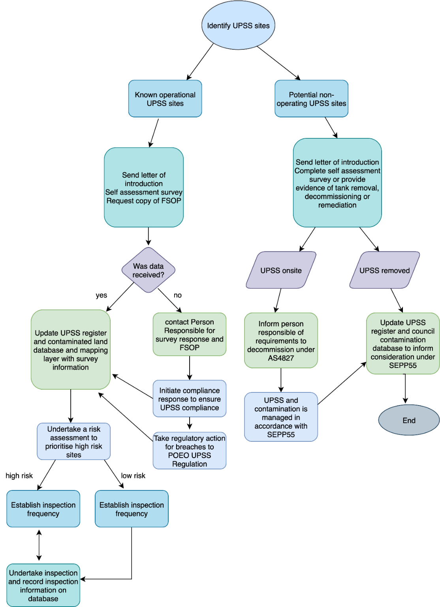

**Figure 1:** Typical process for Councils to obtain and manage UPSS information.

Identify UPSS sites

The identification of UPSS sites in your local government area is critical to the success of a UPSS strategy. Councils can obtain this information from a range of sources including (but not limited to):

* SafeWork NSW Schedule 11 licenced UPSS sites,
* NSW Fair Trading registered service stations (‘Fuel Check’ database),
* NSW EPA list of contaminated land investigations,
* NSW EPA register of regulated contaminated land sites,
* NSW EPA Environmental Protection Licence database,
* Fuel companies, distributors, retailers etc (e.g. Ampol, BP, etc.)
* Council land use planning business processes (Development Application for a new or ‘significantly modified’ UPSS infrastructure,
* Council corporate knowledge and/or existing database knowledge,
* Historical societies,
* Internet searches, and
* Aerial maps and photographs (e.g. Google Maps).

Maintain information on UPSS sites

The maintenance and update of information on these UPSS sites is the key to Council’s managing the corporate risk associated with the operation of these sites.

The following steps are critical in mitigating this risk:

* Periodic survey of UPSS sites to ascertain ongoing compliance with regulatory requirements,
* Risk assessment of survey responses to classify sites as high, medium or low risk in relation to compliance,
* (Optional) Detailed risk assessment of site with a ‘high’ compliance risk to identify sites of overall ‘very high’ or ‘high’ risk rating as a function of vapour intrusion risk, potable water risk and ecological degradation risk,
* (Optional) Develop a UPSS Plan for ‘very high’ and ‘high’ over risk rating sites,
* Implement an inspection and monitoring program of ‘very high’ overall risk rating sites to collaborate on developing an ‘action plan’ with the UPSS owner to reduce the overall risk rating

Information obtained from these steps are required to either establish the baseline for a UPSS site, or to update the baseline. Where applicable, the corresponding record in the CLSR must also be updated. For example, a UPSS owner may advise in its response to the survey that a UPSS tank was decommissioned and the tank pit was remediated. Hence this updated information (including technical reports) must also be reflected in the CLSR.

The periodic survey of UPSS sites is the ‘Environmental Compliance and Self Evaluation survey’. This survey should be sent to all UPSS sites to provide Council with the required baseline information for each UPSS site. Periodic update of this baseline information via this survey should be prioritised:

* Annual survey for sites with overall risk rating of ‘very high’ or ‘high’, and
* Tri-annual for all other sites to confirm ongoing compliance with regulatory requirements.

Responses to the survey must be assessed to ascertain the extent to which the UPSS site complies to the regulatory requirements in relation to leak monitoring, leak detection and having a Fuel System Operation Plan. Additionally, the ‘person responsible’ for the UPSS infrastructure at a given site must be designated.

Templates

A range of templates are available for council to incorporate in their business processes to obtain and maintain data and information in the UPSS register.

Available templates include:

* Letters
* Survey form and cover letter
* Risk assessment
* Forms
  + Leak notification
  + Inspection form and cover letter
* Fuel System Operation Plan
* UPSS Register
* UPSS Plan
  + An optional step for Councils to develop a risk-based approach and structure for its UPSS inspection and monitoring program.
  + Plan template and its underlying detailed risk assessment Excel files

UPSS definitions

Key to the reliability and purpose of the UPSS register is the accuracy of data entered. To ensure clarity and consistency of data entry amongst users, definitions have been developed.

**Underground petroleum storage system (UPSS):** A system of tanks, pipes, valves and other equipment that is designed to:

* Contain petroleum, or
* Control the passage of petroleum into, out of, through or within the system, and
* Includes any structure through which petroleum routinely passes from one part of the system to another.

**Person responsible**: The person who has the management and control of a storage system (this may be different to the site owner). The person responsible is legally required to ensure the UPSS complies with the requirements of the Regulation. Where a corporation is responsible for a UPSS, an individual who is authorised to act on behalf of that corporation must be nominated to the appropriate regulatory authority as a contact.

Where a UPSS is no longer in use but has not yet been decommissioned, the person responsible is the person who had management and control of the system immediately before it ceased operating. If that person cannot be located, the person who owns the land on which the UPSS is located is deemed to be the person responsible.

The terms included in table 1(a) below are the drop-down options when filling in the UPSS register or site inspection checklist. Definitions have been included as some terms are specific to the UPSS Regulation.

**Table 1(a):** UPSS register field header definitions.

|  |  |
| --- | --- |
| Description | Notes/Definition |
| Precis | Current site identifier e.g. BP Hay.  For tank records it also includes the tank number. |
| Address | As per property record – the address of the actual site where the UPSS tanks are situated. |
| Property Title | As per property record |
| Site Owner | NAR (Name and Address Register) |
| Applicant | Person responsible for UPSS as defined by the Regulations.  This is the person responsible for the UPSS system (not necessarily for the day to day operations of the business). |
| Person Responsible Contact Details | Including email, mobile phone, postage address which may be different from actual site |

**Table 1(b):** UPSS register field header and drop-down list items definitions.

| Drop down list | Notes/Definition |
| --- | --- |
| FSOP Status | Fuel System Operation Plan – documentation for a storage system that contains the procedures and other information required by Clause 18 of the UPSS Regulation |
| Complete FSOP | Site has a FSOP in place that has been verified by EHO as compliant with UPSS regulation |
| Incomplete FSOP | Site has a FSOP in place that has been verified by EHO as partially compliant with UPSS regulation.  This includes where an operator nominates a FSOP is in place in a self-assessment and Council is awaiting further information. |
| No FSOP | No FSOP is in place as identified by self-assessment or EHO. |
| Unknown | No information is available as to the status of the FSOP. |
| Leak Detection System |  |
| GW Wells Complete (at least 3 installed) | A minimum of 3 groundwater monitoring wells are onsite. |
| GW Wells Partial (<3 installed) | Less than 3 groundwater monitoring wells are onsite. |
| Alternative | An alternative leak detection system is in place and considered suitable. |
| No Leak Detection | No Leak Detection system is in place |
| Unknown | Unknown – No information is available about the leak detection system |
| FL Monitor Process | Fuel loss monitoring process - One or more procedures to undertake inventory control (reconciliation) of the fuel in a system. The procedure(s) must be able to identify a loss or a gain in the volume of petroleum and have the means to record any identified discrepancy that triggers the need for further action. |
| Automated Compliant | Automatic tank gauging system, combined with fuel delivery, sale data and reconciled through Statistical Inventory Reconciliation Analysis (SIRA). |
| Automated Part Compliant | Tank interstitial monitoring only |
| Automated Non-Compliant |  |
| Manual Compliant | Manual dipping with SIRA reporting |
| Manual Part Compliant | Manual dipping only, no wet stock reconciliation |
| Manual Non-compliant | Manual dipping infrequently or not carried out |
| Unknown | Unknown – No information is available about the loss monitoring system |
| Forecourt |  |
| Compliant | New or modified site with best management practice in accordance with the *NSW EPA Practice Note: Managing run-off from service station forecourts*, e.g. high and low risk zones are separated, canopy covers high-risk zone and forecourt run-off is managed prior to discharge or disposal. |
| Non-compliant | New or modified site where one or more of the follow does not apply: high and low risk zones are separated, canopy covers high risk zone and forecourt run-off is managed prior to discharge or disposal |
| Legacy Issue | Non-compliant but site is old and has not been modified, so there is not requirement to upgrade. |
| Unknown | Unknown as haven’t undertaken a site inspection |
| UPSS Regulated | Appropriate regulatory authority (ARA) |
| NSW EPA |  |
| Council |  |
| Site Status |  |
| Operational | Currently in use |
| Temporary Closure | Site temporarily not in use (Maximum of 2 years before needs to be changed to abandoned or decommissioned) |
| Decommissioned | UPSS is no longer in use & all UPSS tanks have been appropriately decommissioned with validation certificates. |
| Abandoned | UPSS is no longer in use and tanks remain that have not been decommissioned. |
| Tank Info | Number of Operational Tanks (does not include decommissioned or abandoned tanks) |
| 1-10 |  |
| 10+ |  |
| Unknown |  |
| Tank Ages | This will determine if a site must comply with all of the UPSS regulations |
| Pre 1 June 2008 | All tanks on the site were commissioned before 1 June 2008 |
| Post 1 June 2008 | All tanks on the site were commissioned after 1 June 2008 |
| Combination | A combination or pre/post 1 June 2008 and or unknown. |
| Unknown | It is not known when any of the tanks were commissioned. |
| UPSS Risk | Refer to UPSS Risk Ranking Results |
| Low | Post 2008 tanks and GW Monitoring in place and not located in close proximity to a sensitive environmental receptor. |
| Medium | Not low or high risk |
| High | Pre 2008 tanks and no GW monitoring in place and/or known contaminated site and/or status is “Abandoned” |
| Unknown | A risk classification has not been undertaken. |
| Function Status | As outlined on last inspection report completed by EHO. |
| Fully Functional | Fully compliant no follow up inspections required |
| Minor Issues | Mostly compliant, suggestions for improvement made to person responsible, no follow up inspection required |
| Medium Issues | Some issues were identified, a follow up inspection is required within 3 months |
| Major Issues | Major issues were identified that may require compliance action to be taken. |
| Unknown | Unknown if no inspection has been carried out. |

Authority civica upss register

The UPSS register structure

The UPSS register captures operational sites that are regulated by the UPSS Regulation. All UPSS will be listed as potentially contaminated and will also be identified in Council’s CLSR.

The register for a UPSS site comprises of two or more records. Each record is uniquely identified by a number of fields:

* Document type (a number assigned to all UPSS register records, often 116)
* Document year (year the site was added to the register)
* Document number (system generated sequential number assigned to the UPSS site)
* Document Part (number entered to differentiate a site record from a tank record. Part #1 is always represents a site record, Part #2 onwards refers to the tanks on the site. The tank number is also in the Precis (description) field).

For each UPSS site, one record is the site record and the remaining records hold the tank details. A UPSS site will have a common document number for the site and tank records. The difference between a site record and a tank record is the Part Number. A site record is always Part #1.

**NB: Authority always displays the last tank (part number) first when searching for a site (document number). So use the forward arrows to get to the last record to see the site record (part #1). This is a default for Authority.**

In a UPSS site record there is the site base data, a number of Links to property, names and other registers, and two extra data repositories called Tracking and Checklists.

* Base Data. This is the core data for a site and is displayed as per below. It holds information such as the full account number for the record, primary parcel number, description, the person responsible for UPSS site (the field called Applicant) and a display of property information and tracking defaults.

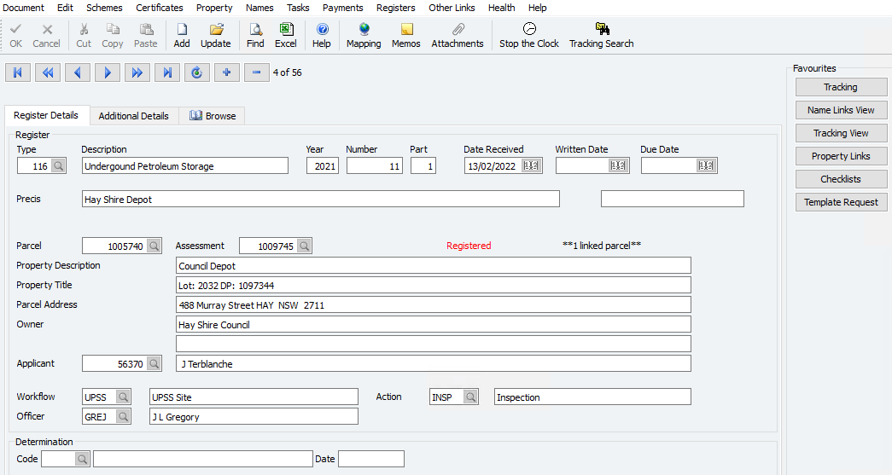

* Property Links. This shows the primary property parcel. Additional parcels can be added if required.
* Names Links. Displays links for the Site Owner, Applicant (Person Responsible) and Site Operator.
* Register Links. This displays any links to other registers such as Contaminated Land
* Tracking (Workflow). Tracking is used to monitor and update actions defined in a Workflow. Workflows have been established; one for Sites (UPSS) and one for Tanks (UPST). The actions can represent things such as Inspections, Decommissioning, Request for Inspection, and Data Entry. Normally the Entry action is completed when adding a new site or a tank. The others are optionally completed when required.
* Checklists. There are a number of checklists, some for the site record and some for the tank record. The checklist holds data relating to a site or tank and is associated with an action taken in the (Tracking) Workflow. The data held varies depending on the action being used (e.g. Inspection data will differ from Compliance data)

**NB: Buttons can be added to the register screen for each of these by using the Edit function on the ring menu at the top of the screen.**

**List of Workflow and checklists**

|  |  |  |  |  |  |
| --- | --- | --- | --- | --- | --- |
| **Chk List** | **Description** | **Workflow** | **Description** | **Action** | **Description** |
| 11601 | UPSS Site Checklist | UPSS | UPSS Site | ENT | Record Entered |
| 11602 | UPSS Site Inspection Details | UPSS | UPSS Site | INSP | Inspection |
| 11603 | UPSS Site Compliance Details | UPSS | UPSS Site | INSP | Inspection |
| 11604 | UPSS Tank Details | UPST | UPSS Tank | ENT | Record Entered |
| 11605 | UPSS Tank Decommissioning | UPST | UPSS Tank | DUPS | Decommission Tank |

New Register Entry/ Entry Update

Select the UPSS register by the menu (most sites use Land / Register / UPSS) or search using ‘UPSS’ as a search key.

Select the required program from either: Enquiry, Data Entry or Update

To avoid duplicate entries on the one parcel ensure a search is done within the register on the parcel number first. If a registry entry already exists update the existing entry rather than create new entry. If no entry exists against the subject parcel create new entry.

### Add / Modify a UPSS site

In Authority, go to Land/Registers/UPSS and select UPSS Enquiry or Entry or Update (as shown below) as appropriate.

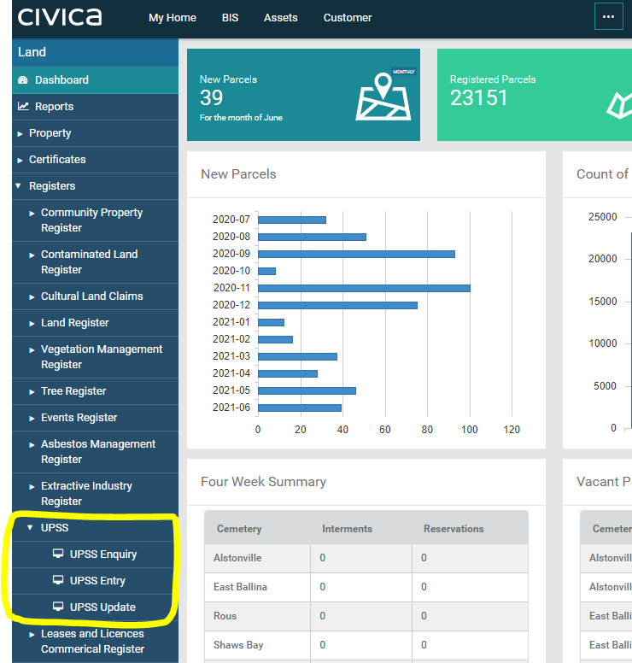

Once selected, this will open a new entry screen at which point ‘ADD’ should be selected from the top menu bar to enable a new entry to be added. The new entry front screen should be completed as shown below:



1. Year will default to the current year. It can be changed to a prior year if required. Once the recorded is added, it cannot be changed.
2. Number should be left blank. It will be assigned when the record is added.
3. The Part should be set to 1 for a Site record. Add the site first then add the tank records afterwards.
4. Precis is the Site description. It should indicate the business and location (e.g. Shell Griffith Road)
5. Parcel should be entered or selected from the dropdown. Additional parcels can be added alter using the Property Links option. The assessment and property details will be displayed after tabbing through the field.
6. Applicant is the person responsible for the UPSS. This may be someone other than the owner or operator. The site operator should added later using the Names Links (see below).
7. The workflow for the Site should always be UPSS. The Tank workflow is UPST. The Action and Officer will default when you tab through the field.

Hit O/K or F12 to add the base data.

### Add additional parcels

If additional parcels are required use the Property Links option (under Property menu). Click on to the next blank parcel field and enter or select the parcel number. Click O/K or F12. You will now see the number of registered parcels displayed on the front screen has increased.

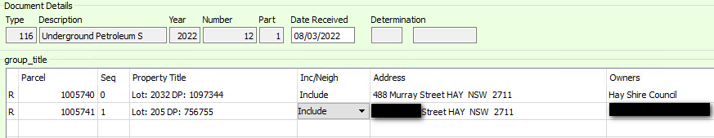

### Add Site Operator and Owner

Select The Names Link option from Names on the ring menu at the top.

Select Update. Click in to the next line available.

For Site Operator use Name Type number that is the same as the Document Type of the register. For example if the Document type is 116 (commonly) the use that. Tab to the nar field. Enter the nar number for the operator. Tab to the next field down. If the name does not exist it will prompt you to add the name. Check with local Council policies regarding adding NAR records.

For Owner enter Name Type 7 (or use selection from dropdown). Enter or select the nar number for the Owner. If it prompts for adding a new name, check you have the correct nar number as the owner should already be in Authority.

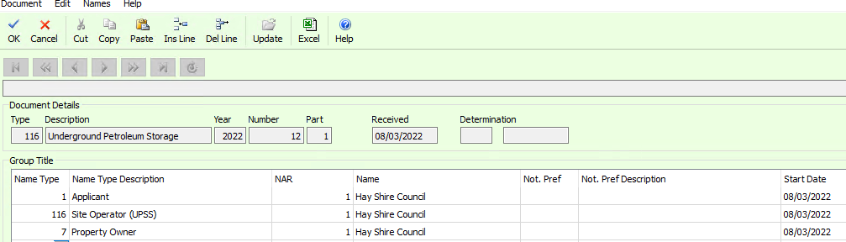

### Add Checklists.

Select the Tracking option (from Tasks in ring menu). **Select Find and O/K.** There should be one tracking item called Record Entered. This is added automatically when you add a site record.

From the Tracking menu at the top of this select Checklist. Select Add when the program starts.

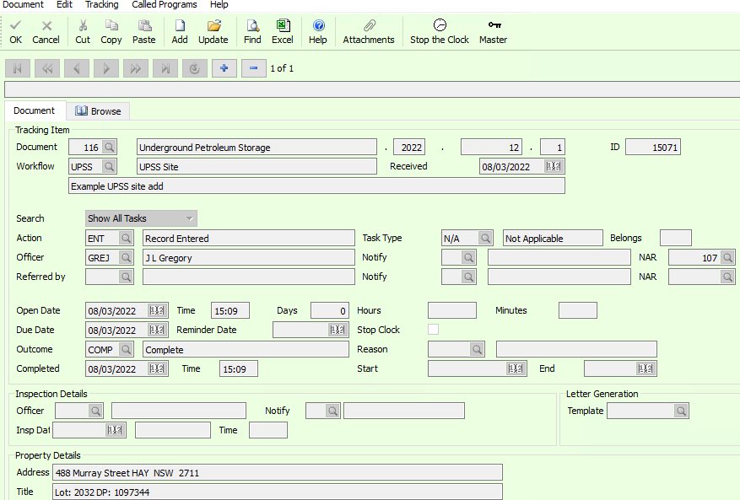

From the Type field use the dropdown menu to select the UPSS Site Checklist. Tab through to Officer and select the officer responsible for the checklist entry.

Tab through to the first checklist. Where the Type is Lookup there should be an option to lookup values. If it is Text then you can enter whatever text is required. A comment box may also appear when a comment is allowed.

Click O/K.

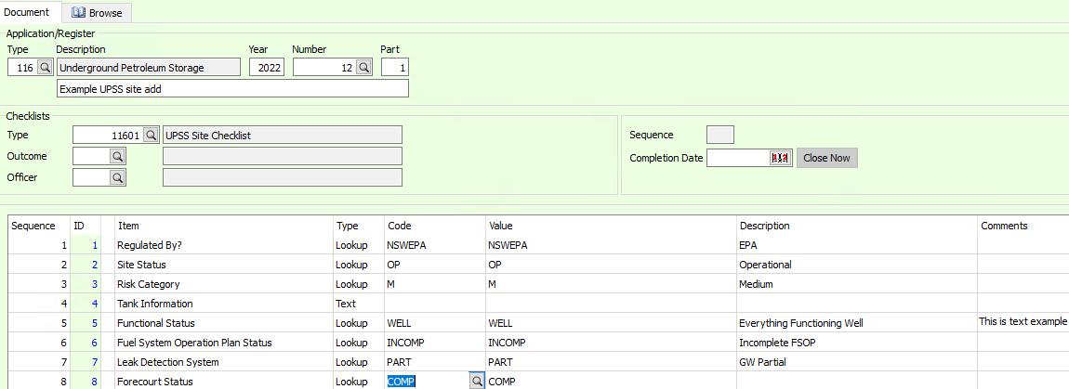

**N.B: The checklists are associated with a task (or action) in a workflow. So if you add a task using the Tracking option, you should also add or update a checklist (if one is available) from the Tracking program.**

**List of Workflow and checklists**

|  |  |  |  |  |  |
| --- | --- | --- | --- | --- | --- |
| **Chk List** | **Description** | **Workflow** | **Description** | **Action** | **Description** |
| 11601 | UPSS Site Checklist | UPSS | UPSS Site | ENT | Record Entered |
| 11602 | UPSS Site Inspection Details | UPSS | UPSS Site | INSP | Inspection |
| 11603 | UPSS Site Compliance Details | UPSS | UPSS Site | INSP | Inspection |
| 11604 | UPSS Tank Details | UPST | UPSS Tank | ENT | Record Entered |
| 11605 | UPSS Tank Decommissioning | UPST | UPSS Tank | DUPS | Decommission Tank |

### Add / Modify Tank record(s)

Complete the steps (you must have added the Site record) as above except:

1. Enter the Document Number associated with the Site record. This links the Tank record to the Site record. The Part Number will default to the next available. Remember Part 1 is used by the Site record, so the first Tank will be Part #2 etc.
2. Enter the tank number as part of the Precis. Use the same description as the Site with the Tank number appended.
3. Enter the workflow as UPST
4. Add the checklist. **Remember to do a Find and O/K first to get the Record Entered task**. Add checklist for the tank details (see below).

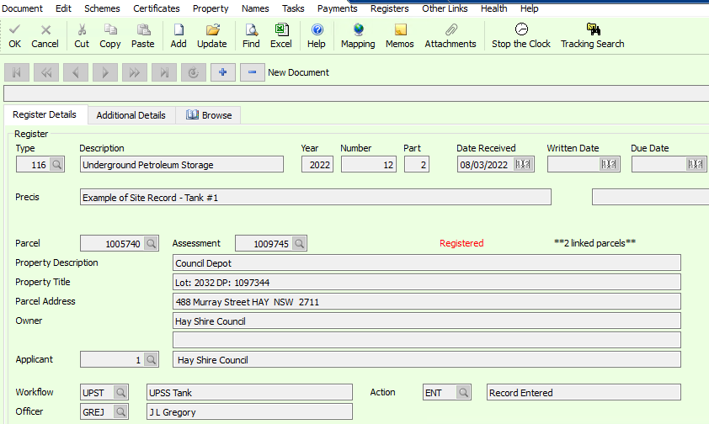

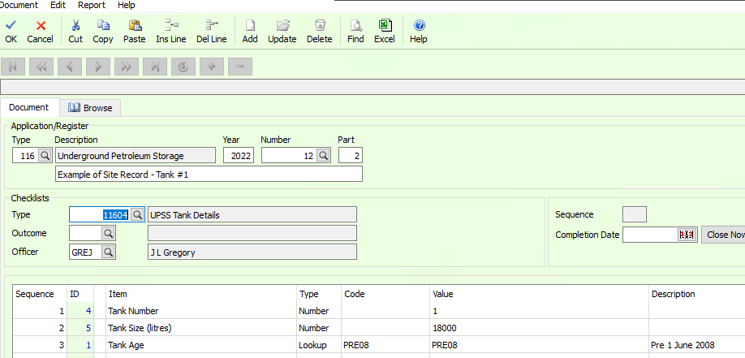

### Add Register Links.

You can add links from the UPSS record to another register such as the Contaminated Land register. Every UPSS record should have a corresponding CLM record.

To add a link, select Register Links from the Register menu at the top of the Site or Tank record, select Update and enter the type, year and number in the next available line. The type will be the Document Type of CLM and the number is the Document Number or the CLM record.

The opposite can be done in the CLM register to link to the UPSS record.

This gives visibility to other register record associated with the UPSS.

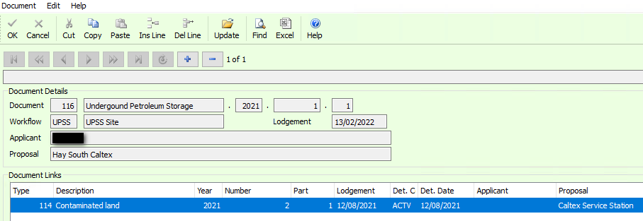

Workflows/Tracking Maintenance

Tracking is used to highlight what actions have been undertaken in relation to each register entry. The following tracking options are in place and should be added as required and closed as each step is completed.

Workflows are established to allow actions to be recorded against the register. The actions can the sequenced and can be mandatory or optional. The only mandatory action is the “Record Entered” action (ENT) that is automatically added when a site or tank record is added. The Site Checklist then needs to be added as per above.

Template actions can be added, updated or deleted using the Workflow Maintenance program (i_dm024) and Action Codes (i_dm016). You need to have Authority Admin permission to access these programs.

The UPSS register has been built with two workflows (one for Site – UPSS, and one for Tanks (UPST). There are a number of action codes (below) that have been also created for UPSS and UPST workflows.

The Tracking option is used in the UPSS register to add actions to a site or tank record. The Tracking View option is used to view the existing actions for a Site or Tank.

**Actions Code used in UPSS workflows**

|  |  |
| --- | --- |
| **Reason Code** | **Description** |
| CEAS | Business Ceased Operation |
| CHAG | Change of Ownership |
| COPR | Change of Responsible Person |
| DECO | Decommissioned |
| DUPS | Decommission Tank |
| ENT | Record Entered |
| FLN | Fuel Leak Notification |
| INSP | Inspection |
| NBN | New Business Notification |
| RFI | Request for Information |
| TCLO | Temporary Closure of Site |

Checklist Maintenance

Checklists have been established to complement the actions in a Workflow. When an action is added to a Site or Tank in the UPSS register (using Tracking) a Checklist can also be added or updated. This allows extra information to be recorded for that UPSS site.

There are five Checklists that have been established against Action Codes. The relationship between the checklist and action code is shown below.

Checklists can be updated if you have Authority Admin rights using i_al045. A sample of the Site Checklist is below.

**List of Workflow and checklists**

|  |  |  |  |  |  |
| --- | --- | --- | --- | --- | --- |
| **Chk List** | **Description** | **Workflow** | **Description** | **Action** | **Description** |
| 11601 | UPSS Site Checklist | UPSS | UPSS Site | ENT | Record Entered |
| 11602 | UPSS Site Inspection Details | UPSS | UPSS Site | INSP | Inspection |
| 11603 | UPSS Site Compliance Details | UPSS | UPSS Site | INSP | Inspection |
| 11604 | UPSS Tank Details | UPST | UPSS Tank | ENT | Record Entered |
| 11605 | UPSS Tank Decommissioning | UPST | UPSS Tank | DUPS | Decommission Tank |

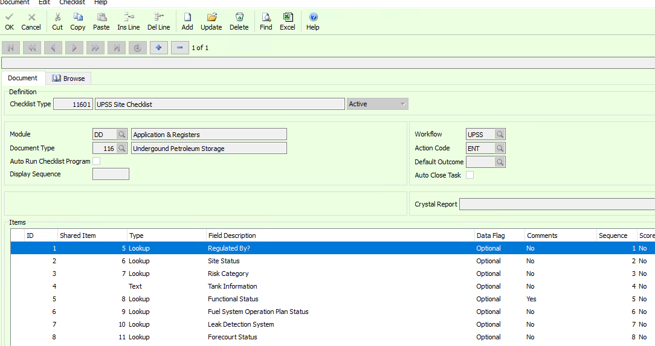

Inspection Updates, Add Tracking Record

Inspections occur on a regular frequency. The UPSS register will need to be updated after an inspection occurs.

There are two stages to entering an inspection in the UPSS register:

1. Add a tracking record. This can be done prior to the inspection and a due date can be entered. It can also be added after the inspection has occurred;
2. Add checklist records. There are two checklists for an inspection. One is the Site Inspection checklist and the other is the Site Compliance checklist (see below).

First add the Tracking record by finding the Site record in the UPSS register. Select Tracking from the top menu or from the side button (if set up).

Select Add.

Enter or select INSP for Action.

Tab to Officer and enter the officer responsible

Tab to Open date and accept default.

Tab to Due date and update or accept.

Tab to Outcome. If not completed deleted the outcome code and Completed date. Otherwise update or accept.

Enter or select the inspecting officer code(initials) and inspection date.

Optionally add notes to the Task Comments field.

Select O/K or F12 to update the record.

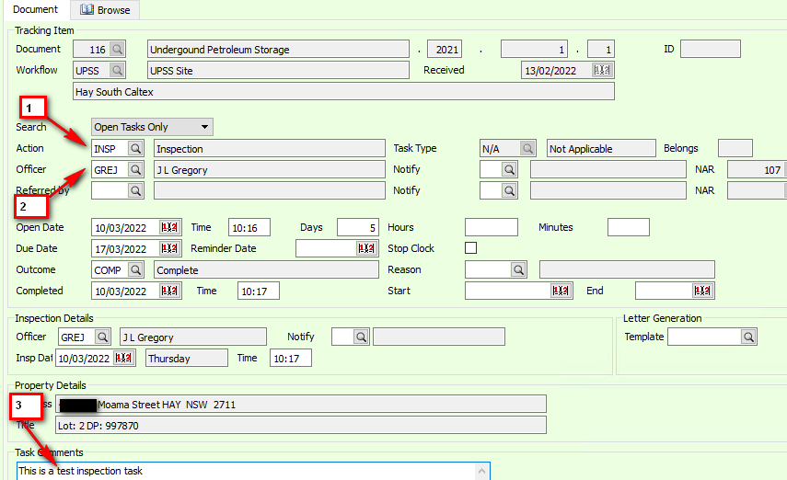

### Add Site Inspection Checklist Record

There are two checklist records for an inspection. One is the Site Inspection and the other is the Compliance checklist

1. From the Tracking option at the top menu, select Checklist.
2. Select Add.
3. Use the dropdown in the Type field to select Site Inspection.
4. Enter or select outcome and date. Usually COMP for Completed.
5. Enter officer.
6. Enter Inspection date in the format dd/mm/yyyy. Tab to next field.
7. If follow up inspections are required enter Y, otherwise N. A Comment box will appear where comments about the follow up can be optionally entered. Tab.
8. If EDMS records need to be updated enter Y, else enter N.

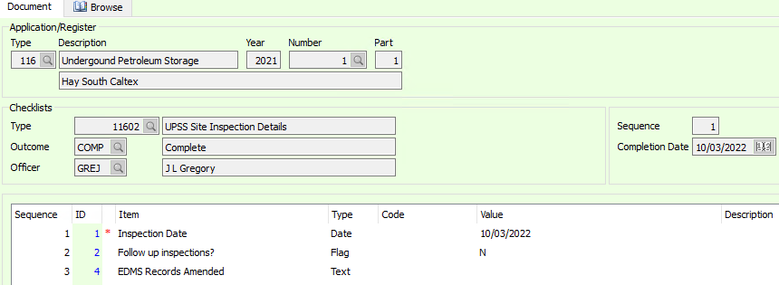

### Update Site Compliance Checklist Record

The second checklist for an inspection is the Site Compliance. It records the outcomes from the inspection. This record is updated only to give the latest compliance status for the site

1. Select Next from the Checklist program (used above – i_al046) until the Compliance record is displayed.
2. Select Update
3. Tab through to the compliance items. Do not enter an outcome.
4. Complete the checklist items as required.
5. Close the checklist and tracking programs down to return to the UPSS register.

**Note:** Flag requires an Y or N, Lookup has a dropdown for a list of values, Text allows a small comment. Comment boxes can appear for Flags which are optional.

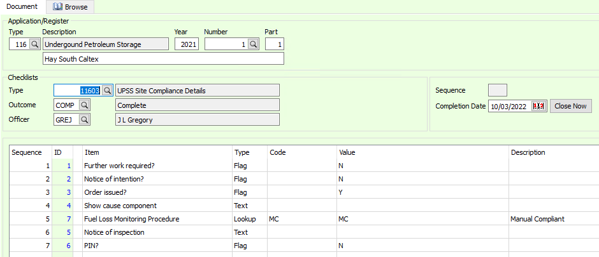

UPSS registers in alternative corporate IT systems

Not all council’s use Authority Civica as their enterprise resource planning system (ERP) or for their UPSS register. While this user guide has a core focus on a Civica Authority UPSS registers, this section of the user guide provides some general guidance for managing UPSS registers in alternative corporate IT systems.

Corporate mapping systems

There are a number of councils that have incorporated its CLSR in their corporate mapping system (e.g. Bland Shire Council and MapInfo). The CLSR exists as a layer in this system.

Your Council was provided an Excel version of the UPSS register in 2022. Hence the question of whether to supplement the CLSR layer with the UPSS register. This undertaking would require specific expertise in the mapping system to successfully upload the Excel version of the register.

Additionally, this would require all records in the Excel version of the UPSS register to include Lot, section, deposited plan and parcel numbers for each record. This information can be obtained from Council’s mapping system and confirmed by information provided by UPSS sites in response to the Environmental Compliance and Self Evaluation survey.

The steps to obtain, assess, maintain and update data and information for each UPSS site is the same as the steps outlined in guidance described earlier in this user guide.

However, under this scenario there are key departures from the guidance described earlier in this user guide. These departures pertain to functions of Authority Civica that add value to the process. These include the draw down of templates and the linkages to the CLSR and EDRMS (HP Trim), which may not be available (or exist as a feature) in your Council’s mapping system. Specific examples of departures include:

* Manual draw down of templates for letters/correspondence, inspection forms, etc, and manual saving of these to the EDRMS,
* Manual link to the CLSR,
* Authority Civica workflows, and
* For Authority ACTUS Councils, the ability to take the UPSS register into the field and access and update records, letters and forms in real time.

If your Council seeks to upload the Excel version of the UPSS register into its mapping system, then the following additional guidance is suggested in relation to developing procedures:

* For the maintenance and update of UPSS data and information, and mapped to specific Council business processes
  + statutory planning – how to create or update a UPSS record with information from a Development Application for a new or ‘significantly modified’ service station
  + inspectoral functions – how to update a record with inspection outcomes and/or inspection after receipt of a notification (UPSS leak notification, house fires, etc)
  + records management in relation to EDRMS procedures, concurrent update of the CLSR and templates, OR
  + System administrator to create, maintain and/or update the UPSS record with data and information from the above business processes
* On how to use defined templates in Council business processes (letters, survey form, inspection forms, etc)

The key risk of this scenario is the capability of Council to manage UPSS data and information in mapping systems.

Microsoft Excel UPSS register

This scenario is for Council that intend to maintain and update UPSS records using the Excel version of the UPSS register provided to them as part of the RAMJO-REROC CRCB project.

This scenario would require a designated resource to create, maintain and update UPSS records in the Excel UPSS register. The steps to obtain, assess, maintain and update data and information for each UPSS site is the same as the steps outlined in guidance described earlier in this user guide.

However, under this scenario there are also key departures from the guidance described earlier in this user guide. These departures pertain to functions of Authority Civica that add value to the process. These departures are the same as those mentioned in the previous section (mapping systems) including mitigation steps (i.e. development of procedures).

The risks of this scenario are:

* The probable static nature of the register in the absence of a designated resource responsible for the register, and
* Lack of integration in Council business processes, thereby not used in land use planning and inspectorial functions,

Alternative ERP

This section is blank as there was insufficient grant funds to explore the requirements to incorporate the UPSS register in an alternative ERP such as TechOne.

Hence Councils are advised that in-lieu of a budget to seek professional services to achieve this outcome, they should interact with the Excel version of the UPSS register. Considerations and risks mentioned in the previous section are relevant here.

No UPSS register

Councils that do not have a UPSS (or CLSR) register are strongly urged to develop each.

This recommendation is underpinned by the fact that councils are required to ensure land us suitable for its proposed use, and to minimise the risk of harm to human health and the environment. Contaminated land and UPSS data and information can only be obtained from these registers.

If you Council seeks to develop a UPSS and CLSR registers, then contact […] for advice on how to plan, prepare, develop and maintain each. Alternatively, you could reach out to a council that you know was involved in one of the 9 CRCB projects across NSW. Further information on the councils that participated in this program can be found on the NSW EPA website.