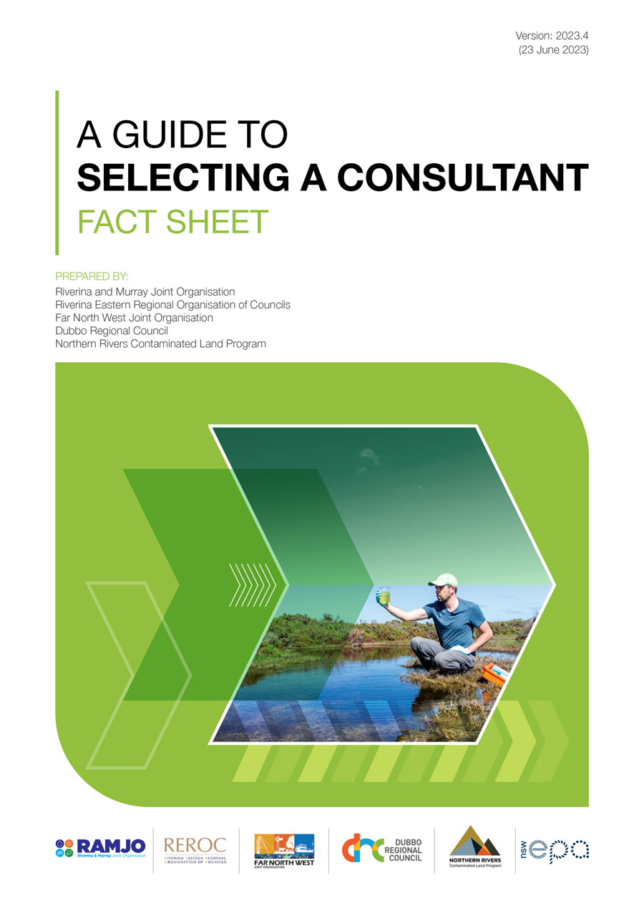

Aim
Councils rely on consultant reports to make decisions about land-use suitability and assess the risk of harm that contaminated land poses to human health and the environment. Therefore, it is important that Councils are able to have a high degree of confidence in using these reports in their land-use planning and development control processes.

Introduction
Reports developed by consultants must comply with relevant policies and statutory contaminated land guidelines. However, it can be difficult to determine whether a consultant has the required technical competency and experience to undertake the work.
Poor-quality contaminated site reports can lead to delays in Council’s land-use planning and development control processes. Importantly, it can also delay the clean-up and regulation of contaminated sites, and it can increase costs for the landowner or occupier.
This fact sheet identifies the different types of contaminated land consultants and relates each type to the required competencies and qualifications as defined in legislation and statutory guidelines.
This information is provided with the sole intent of guiding and informing Council staff on what consultant qualifications, competencies and experience are required for the consideration of contaminated land management (including investigations and assessment) and underground petroleum storage system (UPSS) processes (design, installation, operation, maintenance and decommissioning) in Council’s land-use planning and development control processes.
There is an additional section in this fact sheet on the consultant qualifications, competencies and experience required:
- to manage site contamination associated with asbestos and the subsequent works for its handling and removal
- for undertaking the assessment requirements prescribed in the guidelines established by Chapter 3 (‘Hazardous or Offensive Development’) of the State Environmental Planning Policy (Resilience and Hazards) 2021 (Resilience and Hazards SEPP).
Ensuring that the consultant is appropriately qualified and experienced and has adequate professional indemnity insurance for the work to be undertaken will significantly assist Council in managing its corporate risk.
Reports not prepared by suitably qualified consultants may result in increased liability on Council in regard to its ability to demonstrate that it has acted substantially in accordance with the contaminated land planning guidelines as defined in Schedule 6(3) of the Environmental Planning and Assessment Act 1979.

Other available capacity resources
This fact sheet is part of a series of resources developed to guide and inform Council land-use planning and development control processes. Collectively, these resources are intended to provide instructional and procedural guidance to enable Council to:
- ensure land is or can be made suitable for its proposed use
- minimise the risk of harm to human health and the environment from a use of land.
- apply good practice to land-use planning and development control processes in achieving the above objectives.
Other resources related to this fact sheet provide additional instructional and procedural information on the selection and use of consultants. These include:
- the Assessment of Site Contamination Reports quick reference guide – which can assist Council to navigate the assessment of site contamination process
- ‘Contamination Report Summary Table’ (Appendix 8 of the Assessment of Site Contamination Reports) – a checklist that can be provided by Council to consultants to ensure reports provided to Council include all information that is required to be included in a report on the assessment of site contamination
- The UPSS Systems and Council ARA Responsibilities quick reference guide – which provides UPSS-specific guidance to Council on incorporating the design, installation, operation and maintenance of UPSS infrastructure in development control processes
- the Managing Offsite Transport of Soil quick reference guide – which provides advice to Council on managing the development control process requirements related to the export or import of soil from a development site
- the Managing Asbestos in Development Control Processes quick reference guide – which provides advice to Councils on managing asbestos in development control processes.

Engaging contaminated land management consultants
Contaminated land can present a range of issues that require technical expertise. Not all contaminated land consultants will have the relevant skills or qualifications in contaminated land assessment and remediation.
It is best practice to ensure that a competent and appropriately qualified contaminated land consultant is used in instances where there is a high risk of liability on Council in regard to site contamination. This could be a potentially or actually contaminated site that has a purpose or a proposed purpose of residential, child care, education, recreational or hospital (that is, a sensitive use).
A contaminated land consultant can undertake (and prepare a report on) an assessment of site contamination for a site not regulated by the EPA. It is considered best practice for Council to require this report to be ‘independently reviewed’ by a consultant certified under one of the two schemes recognised by the EPA. This independent review would confirm that the work has been undertaken in accordance with current regulation and guidelines, and provide Council with greater certainty and confidence in the process and on the report on the assessment of site contamination.
NSW EPA-accredited site auditors can also be used by Council to ‘independently review’ the work of contaminated land consultants. These auditors must be accredited under Part 4 of the Contaminated Land Management Act.

Where to find a contaminated land management consultant
Council is often asked where to find a contaminated land consultant or a duly qualified person for UPSS-related requirements. Council and the NSW Environmental Protection Authority (EPA) do not recommend specific consultants. However, the EPA provides information and guidance on its website to help businesses and individuals select a contaminated land consultant in NSW.
Important commercial aspects to consider before engaging a consultant are their:
- professional and ethical reputation
- documented procedures for completing a project, including a quality control and quality assurance program
- production of reports in accordance with the statutory guidelines made or approved by the NSW EPA under section 105 of the Contaminated Land Management Act 1997 (CLM Act)
- ability and availability to complete projects on budget and on schedule
- having an appropriate level of insurance cover (both professional indemnity and public liability insurance).

Consultant certification schemes
Consultant certification schemes recognise consultants who demonstrate (via an application process) that they meet the required competency standards to carry out the work. These schemes aim to improve the minimum standard of contaminated land work carried out by practitioners and increase confidence in the profession.
NSW EPA currently recognises 2 certification schemes in relation to contaminated land:
- Environment Institute of Australia and New Zealand – Certified Environmental Practitioner (Site Contamination) (CEnvP (SC))
- Soil Science Australia – Certified Professional Soil Scientist Contaminated Site Assessment and Management (CPSS CSAM)
NSW EPA requires the use of CEnvP-accredited consultants to prepare the reports of site contamination assessments for sites regulated by the EPA (that is, for significant contaminated sites regulated under the CLM Act).

NSW EPA-accredited site auditors
Accredited site auditors can be engaged to undertake an independent review of any or all stages of the contaminated land investigation and reporting process. They will ensure that the methods and interpretation of data are consistent with EPA statutory requirements and guidance.
A site auditor can also provide greater certainty about the information on which a planning authority is basing its decision, particularly where sensitive uses are proposed on contaminated land (or adjacent land), and a statement about the suitability of the site is required.
If a planning authority considers that it needs a site audit to make its planning decision, the cost should be borne by the proponent and not the planning authority.
A site audit will produce a site audit report and a site audit statement. The site audit report will present the information and include a discussion and rationale in support of the conclusions made in the site audit statement. A site audit statement is an EPA-generated form that includes the current or proposed land-use activities that are suitable for the site. Only site auditors accredited by the EPA can issue site audit statements.
Accredited site auditors are highly skilled consultants. Therefore, requesting a site audit will cause the project to incur additional cost and time delays. A site auditor is best engaged at the beginning of the project to minimise the potential for work to have to be redone by the consultant.

NSW site auditor scheme
Site auditors are accredited by the EPA under the CLM Act. They are environmental professionals with demonstrated expertise and broad experience in the assessment and remediation of contaminated sites and have a good understanding of relevant NSW legislation, regulations and guidelines.
The NSW site auditor scheme provides a pool of accredited site auditors who can be engaged to review investigation, remediation and validation work done by contaminated land consultants.

When is a site audit necessary?
According to the contaminated land planning guidelines under the Resilience and Hazards SEPP, a site audit is only necessary when the planning authority:
- believes on reasonable grounds that the information provided by the proponent is incorrect or incomplete
- wishes to verify that the information provided by the proponent adheres to appropriate standards, procedures and guidelines
- does not have the internal resources to conduct its own technical review.
Council’s Contaminated Land Policy may outline when the use of an accredited site auditor is required. They are often required on complex or controversial projects and also in instances where full remediation was not feasible, and the contamination is being managed under an ongoing environmental management plan that will typically require an independent third party to ensure that the provisions of the management plan are being maintained.
Table 1 summarises the types of consultants and the key points to assist in determining what type is required.
Table 1: Summary of competencies and qualifications required of contaminated land consultants
Type of consultant | Skills and qualifications | When to use | Considerations
Contaminated land consultant | Relevant tertiary qualifications  Usually self-determination of whether suitably qualified | Routine contaminated land assessments (for example, preliminary site investigation for a residential development)  Council is aware of local issues or location-specific contaminating activities (for example, orchards or sheep dips)  In instances of low contamination risk and complying development pathway | May cover many smaller, often regional, consultancies  Most affordable option (if work is done correctly)  Hard to determine if a consultant has the right experience
Certified contaminated land consultant | Relevant tertiary qualifications  Approved by one of 2 certification schemes recognised by the NSW EPA | More complicated contaminated land assessments or assessments where more than one medium has been affected by contamination, such as soil and groundwater, or groundwater and soil vapour  When there is a higher risk of exposure from contamination (for example, proposed sensitive receptors – residential, child care centres)  When the report is likely to be referred to the EPA, such as when determining if a site is significant enough to warrant regulation | Council policy may require that all contaminated land assessments be undertaken or reviewed by a certified consultant  The certification is general and does not guarantee that the consultant has the relevant specific expertise  Typically more expensive than a consultant assessment
NSW EPA-accredited site auditor | Relevant tertiary qualifications  Accredited by the EPA under the Contaminated Land Management Act 1997  Must demonstrate a minimum competency across a range of topics and have a team of specialists to support them | When greater certainty is required about the information on which the planning authority is basing its decision  When a statement about the suitability of the land or site is required  Often required on complex or controversial projects or where Council lacks confidence in the details of a consultant’s report  Required in instances where the contamination is managed under an environmental management plan, to provide independent verification that the provisions of the management plan are being maintained | Will provide access to competent technical advice  Can be very expensive and may require substandard work to be repeated  Much slower than both other types of consultant  Site audit reports and statements must follow EPA statutory guidelines  Site audit reports are audited by the EPA  Can be required by law (that is, a statutory site audit).  A Council Contaminated Land Policy may outline when the use of a site auditor is required
Note: EPA = Environmental Protection Authority.

Asbestos consultants and contractors
When dealing with contamination that involves asbestos, it is imperative that Council properly identify and confirm the presence of asbestos. A licensed asbestos assessor should be engaged to both identify any asbestos and undertake any required removal.
SafeWork NSW is responsible for licensing these activities. SafeWork NSW’s website provides important information on the regulation of asbestos, along with guidance on the required type and qualifications of an asbestos consultant or contractor.
SafeWork NSW advises Councils to use licensed asbestos professionals for asbestos removal. There are different types of licensed professionals. These are set out in Table 2.
Table 2: Summary of competencies and qualifications of professionals licensed for asbestos removal
Type of consultant | Skills and qualifications | When to use
Competent person | VET certification for asbestos assessor work  Tertiary qualification in occupational health and safety, occupational hygiene, science, building, construction or environmental health | A clearance certificate is required to be provided by an independent competent person (or asbestos assessor) prior to the reoccupation of the premises
Asbestos assessor | Specified VET course for asbestos assessor work, or a tertiary qualification in occupational health and safety, industrial hygiene, science, building construction or environmental health  Possess a licence for friable asbestos assessor work | Licensed for air monitoring or clearance certificates  Clearance certificates for the removal of friable asbestos to be issued by independent assessors  Clearance certificates issued by a competent person or asbestos assessor for the removal of non-friable asbestos  Independent assessors are persons that are independent of the asbestos removal works and have acquired the relevant training and experience
Asbestos removalist and supervisor | Proof of ‘Remove friable asbestos’ and ‘Supervise asbestos removal’ training certified by a Justice of the Peace, and at least 3 years of experience, including at least 3 Class A asbestos removal jobs | Required for all licensed Class A (friable) asbestos removal works  Supervisor must be readily available for all non-friable asbestos removal  Class A licence – can remove any amount of friable and non-friable asbestos  Class B licence – can remove more than 10 square metres of non-friable asbestos  No licence is required for the removal of less than 10 square metres
Note: VET = vocational education and training.
Council, businesses and home owners must always use a licensed asbestos professional to remove friable asbestos or when there is more than 10 square metres of non-friable (bonded) asbestos.
However, due to the risks associated with disturbing asbestos, SafeWork NSW recommends the use of a licensed asbestos professional to assess and remove any amount of non-friable asbestos. The SafeWork NSW website has a list of current licensed asbestos assessors and removalists.
A licensed professional remover of asbestos must complete a SafeWork NSW–recognised training course. Only SafeWork NSW–approved training providers can provide training and issue licences.

Underground petroleum storage systems consultants and contractors
The terminology for UPSS consultants and contractors is outlined in the Protection of the Environment Operations (Underground Petroleum Storage Systems) Regulation 2019 (UPSS Regulation).
Council is the designated appropriate regulatory authority under the UPSS Regulation. Thus, Council has the responsibility to consider the requirements of this regulation in the development control process when:
- a development application seeking new or significant modification of UPSS is received
- inspecting UPSS infrastructure to verify that it maintains compliance with the legislated requirements, including the generation of loss monitoring and leak detection reports.
In accordance with the UPSS Regulation and the EPA’s Guidelines for Implementing the Protection of the Environment Operations (Underground Petroleum Storage Systems) Regulation 2019 (UPSS Guidelines), specific competencies and expertise are required in the design, installation, modification, testing, maintenance and decommissioning of UPSS infrastructure. In most cases, this refers to a duly qualified person who has competence and experience in relation to an activity that is either:
- recognised by a peak body in the relevant industry as appropriate for that activity
- recognised generally by the relevant industry as appropriate for that activity.
It is important for Council to note that the Australasian Convenience and Petroleum Marketers Association has launched a National Petroleum Contractors Recognition Scheme to assist in identifying a duly qualified person. This is an extremely useful resource for Council to draw on in its development control processes.
Duly qualified persons of different specialisations are required for undertaking different components or stages of an activity, such as those listed in Table 3.
Table 3: Professionals required for different components of a UPSS activity
UPSS activity | UPSS professional | Qualification required? | Peak body examples
Design and installation of UPSS infrastructure | Architects, engineers and specialist tradespeople | Yes | ACAPMA, AIP, Engineers Australia
Tank testing and maintenance (integrity testing) | UPSS contractor | Yes | ACAPMA, AIP, Australian Institute of Dangerous Goods Consultants, Motor Traders’ Association of NSW
Loss monitoring system (SIRA) | UPSS contractor | Yes
Leak detection system management (groundwater monitoring) | Environmental practitioner or consultant | Yes | ACAPMA, AIP, Engineers Australia
Note: UPSS = underground petroleum storage system; ACAPMA = Australasian Convenience and Petroleum Marketers Association; AIP = Australian Institute of Petroleum; SIRA = statistical inventory reconciliation analysis.

Reporting requirements
A report prepared by a duly qualified person in accordance with UPSS Guidelines is to describe how a UPSS was decommissioned and outline how the UPSS site was assessed and whether contamination was identified.
Council should consider adopting a procedure whereby they request that the person responsible for UPSS decommissioning notify Council upon identifying contamination during a decommissioning process. A detailed checklist for consultant reporting following the decommissioning, removal or replacement of a UPSS can be found in Table 7 of Appendix 6 of the UPSS Guidelines.
Additional guidance material, such as factsheets and practice notes about UPSS and UPSS infrastructure processes, are provided on the EPA website to help industry stakeholders and local Councils carry out their functions for sites with UPSSs.

Analysis requirements for hazardous and offensive development
Councils are required to consider whether a proposed development is hazardous or offensive prior to making a determination. This applies to development for the purpose of industry and storage, which includes storage of dangerous goods in UPSSs at service stations.
The process of assessing whether a proposed development is hazardous or offensive is set out in the guidelines established by Chapter 3 of the Resilience and Hazards SEPP. The Hazardous and Offensive Application Guidelines – Applying SEPP33 (SEPP33 Guidelines) outlines the land-use safety planning considerations and analysis requirements that Councils are to consider before making a determination on a proposed development.
Essentially, land-use safety planning seeks to create enough spacing between hazardous facilities and other land uses. Development applications for development for the purpose of industry and storage will include reports prepared in accordance with the SEPP33 Guidelines. These reports will need to be assessed by Council prior to any determination on the proposed development.
Councils can be confident in the rigour of these reports if the analysis undertaken is consistent with the SEPP33 Guidelines and if the analysis was undertaken by a competent and experienced consultant.
Council staff are recommended to visit the Australian Institute of Dangerous Goods Consultants website to locate a competent and experienced consultant.
Council staff seeking detailed procedural and instructional guidance on land-use safety planning in the context of proposed UPSS sites should rely on the SEPP33 Guidelines.

Acknowledgements and report limitations
This fact sheet is part of a series of best practice resources developed for Council on contaminated land and UPSSs. These resources were developed with the use of funds under the NSW EPA Council Regional Capacity Building (CRCB) program on contaminated land.
The process of developing these resources was a collaboration between the respective CRCB projects delivered by the Riverina and Murray Joint Organisation, Riverina Eastern Regional Organisation of Councils, Northern Rivers Contaminated Land Program, Far North West Joint Organisation and Dubbo Regional Council.
The following limitations are to be noted in relation to this resource:
- The legislative framework is the framework of 1 June 2023.
- NSW EPA and other statutory and non-statutory guidelines, technical notes and related resources are of 1 June 2023.

The guidelines to which this refers is the Managing Land Contamination: Planning Guidelines: SEPP55 – Remediation of Land. This set of guidelines relates to Chapter 4 of the Resilience and Hazards SEPP, the content of which was previously State Environmental Planning Policy No. 55 – Remediation of Land.
https://www.epa.nsw.gov.au/your-environment/contaminated-land/managing-contaminated-land/engaging-consultant
Currently, Managing Land Contamination: Planning Guidelines: SEPP55 – Remediation of Land (https://www.epa.nsw.gov.au/-/media/epa/corporate-site/resources/clm/managing-contaminated-land-guidelines-remediation.pdf)
See the Assessment of Site Contamination Reports quick reference guide for further information regarding ongoing environmental management plans.
https://www.safework.nsw.gov.au/hazards-a-z/asbestos
https://www.safework.nsw.gov.au/asbestos-and-demolition-licence-holders
https://www.safework.nsw.gov.au/licences-and-registrations/registered-training-organisations
https://www.epa.nsw.gov.au/your-environment/contaminated-land/upss/resources-for-implementing-upss
https://acapma.com.au/our-services/contractors/
https://www.epa.nsw.gov.au/your-environment/contaminated-land/upss/resources-for-implementing-upss
https://www.epa.nsw.gov.au/your-environment/contaminated-land/upss/resources-for-implementing-upss
Dangerous goods are substances that are corrosive, flammable, combustible, explosive, oxidising or water-reactive or have other hazardous properties. Dangerous goods can cause explosions, fires, serious injury, death and large-scale damage.
State Environmental Planning Policy No. 33 – Hazardous and Offensive Development was transferred over to Chapter 3 of the Resilience and Hazard SEPP, which was gazetted in March 2022. The Hazardous and Offensive Application Guidelines – Applying SEPP33 remains the guidelines for Councils to apply this policy.
https://aidgc.org.au/find-a-consultant/#!directory/map/ord=rnd

